Pose Estimation

# Reference

<https://github.com/CMU-Perceptual-Computing-Lab/openpose>

<https://github.com/Daniil-Osokin/lightweight-human-pose-estimation.pytorch>

<https://www.fritz.ai/pose-estimation/>

# Environment Version

## dGPU

Ubuntu : 18.04.5

Python : 3.6.9

GRAPHICS CARD : RTX3090

NVIDIA DRIVER : 455.32.00

CUDA : 11.1.1

cuDNN : 8.0.5.39-1

Pytorch : 1.7.1

## Jetson

JetPack : 4.5.1

CUDA : 10.2

TensorRT : 7.1.3

# Python With TensorRT

<https://spyjetson.blogspot.com/2020/08/xavier-nx-nvidia-ai-iot-human-pose.html>

# DeepStream

<https://developer.nvidia.com/blog/creating-a-human-pose-estimation-application-with-deepstream-sdk/>

## Topology

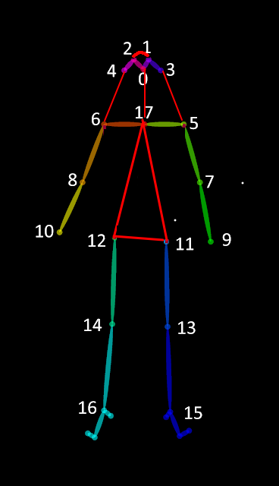

## Path

cd /opt/nvidia/deepstream/deepstream-5.1/sources/apps/sample_apps/deepstream_pose_estimation/

## Build

(x86)

sudo apt-get install libgstreamer1.0-dev

(x86)

sudo apt-get install libgstreamer-plugins-base1.0-dev

sudo apt install libjson-glib-dev

make

## Run

./deepstream-pose-estimation-app ../../../../samples/streams/sample_720p.h264 /home/minggatsby/

# Convert PTH To ONNX To Engine

<https://forums.developer.nvidia.com/t/conversion-of-model-weights-for-human-pose-estimation-model-to-onnx-results-in-nonsensical-pose-estimation/164417/11>

add opset_version=11

/usr/src/tensorrt/bin/trtexec --onnx=pose_estimation.onnx --workspace=2560 --fp16 --saveEngine=pose_estimation.onnx_b1_gpu0_fp16.engine

ONNX Version檢查

<https://github.com/onnx/onnx/blob/master/docs/Versioning.md>

# Classification Pose

<https://spyjetson.blogspot.com/2019/12/jetsonnano-human-pose-estimation-using.html>

# Issue

DeepStream json-glib problem

<https://stackoverflow.com/questions/56085755/how-to-solve-a-problem-of-including-json-glib-h-in-a-c-file>

Convert File

ffmpeg -i test.mp4 -an -vcodec libx264 -crf 23 test.h264

ffmpeg -i test.mkv -c copy test.h264